**Question 1**

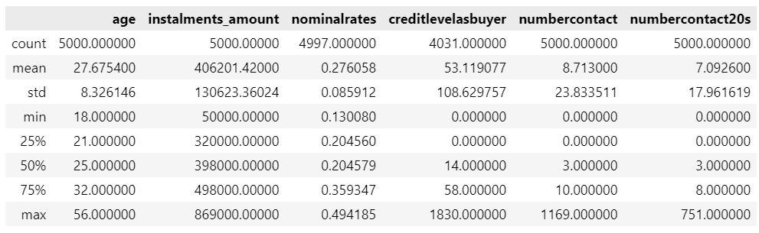

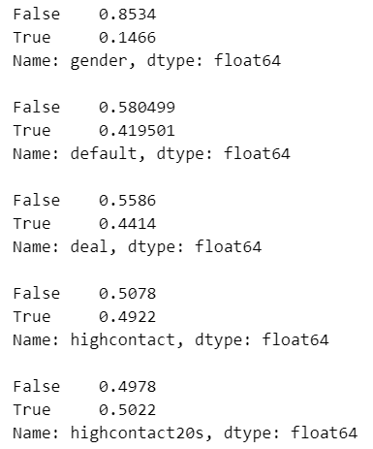

**Question 2**

It can be seen from the table below that the lower credit score is, the higher the likelihood of default is.

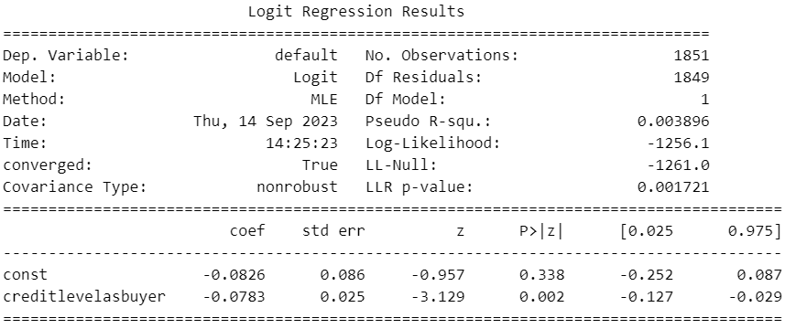

**Question 3**

It can be seen from the table below that the lower credit score is, the higher the likelihood of approval is.

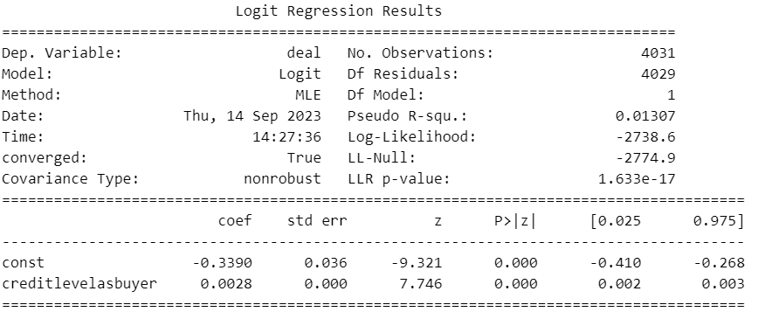

**Question 4**

It can be seen from the table below that the more frequently a borrower has contact, the more likely he/she is going to be approved.

